**Reflective Essay on Machine Learning Module**

ePortfolio: https://gpessoaamorim.github.io/portfolio/#machine_learning

# Introduction

The learning objectives for this module included exploring theoretical concepts underpinning machine learning algorithms, developing and applying these algorithms to specific real-life problems, and learning how to interpret and critically assess their outputs. For this reflective piece, I used Rolfe et al’s approach to critical reflection (Rolfe, Freshwater and Jasper, 2001) together with Gibbs learning cycle theory as a general framework (Gibbs, 1988), by describing module outcomes (WHAT, or Description), discussing my learning journey (SO WHAT, or Feelings/Evaluation/Analysis), and finally reflecting upon my learning outcomes and their application going forward (NOW WHAT or Conclusion/Action Plan).

# Activities performed and learning outcomes (“WHAT”)

The main focus of this module was on using Python to develop data mining and machine learning algorithms, both individually and within a collaborative group. Key tasks included data preprocessing, feature engineering, model training, performance evaluation, and output communication. The module provided a solid foundation in supervised and unsupervised learning techniques, including regression, classification, and clustering, and involving algorithms spanning from simple linear regression to deep learning architectures. For this purpose, I engaged with the recommended learning materials, completed all formative activities, documented my work using Jupyter Notebooks, and produced final reports in both written and visual forms.

My work was hosted on GitHub (https://github.com/gpessoaamorim/portfolio) to create a structured ePortfolio, developed using HTML and CSS by leveraging a pre-existing template, but with substantial reformulation. It was also expanded to include all outputs from previous modules in this course, as well as my CV and other information to become a wider public-facing professional webpage. The screenshots below show some example views of the resulting page, HTML and CSS files being edited in VS Code, and Git BASH being used to host these files.

**Figure 1 – ePortfolio (landing area)**

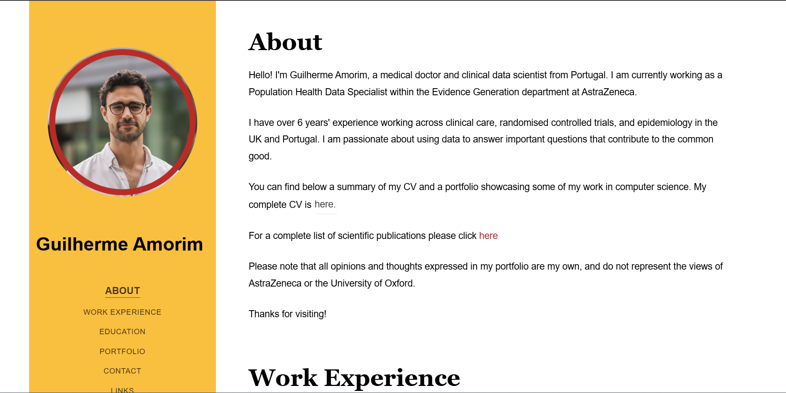

**Figure 2 – ePortfolio (portfolio contents section)**

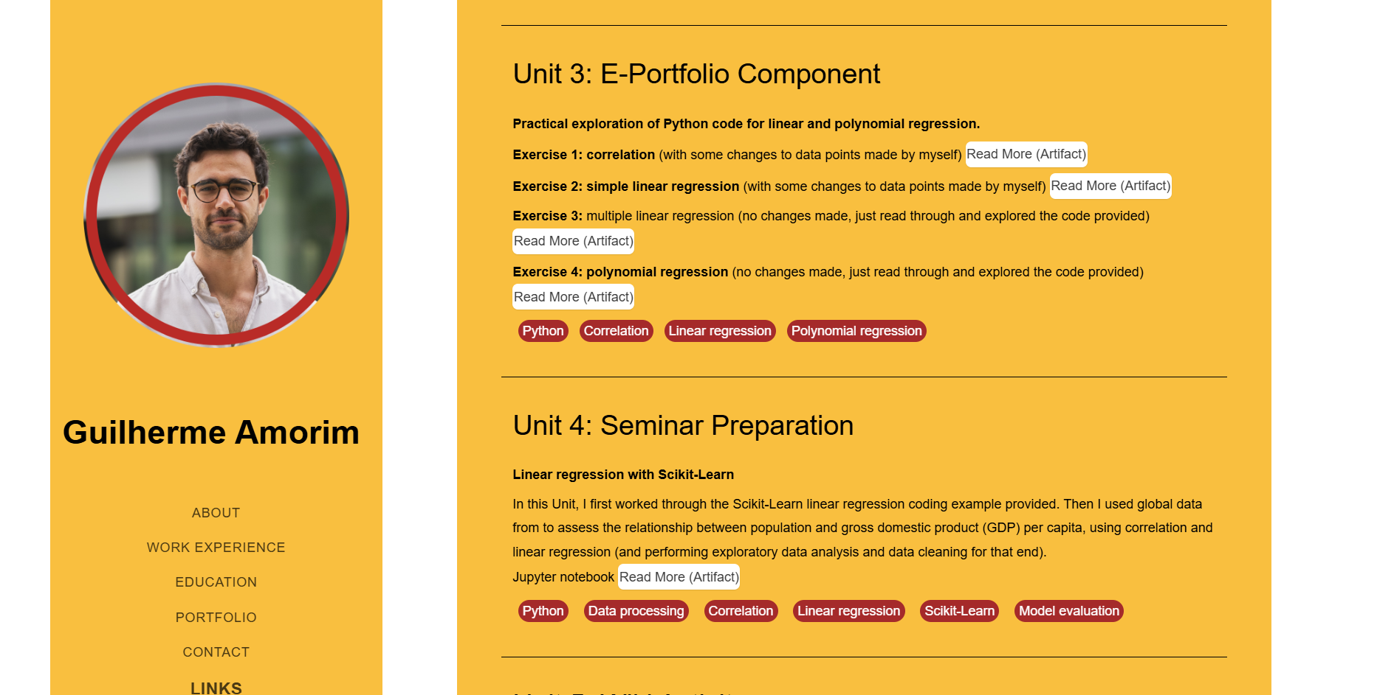

**Figure 3 – HTML and CSS file editing in VS Code**

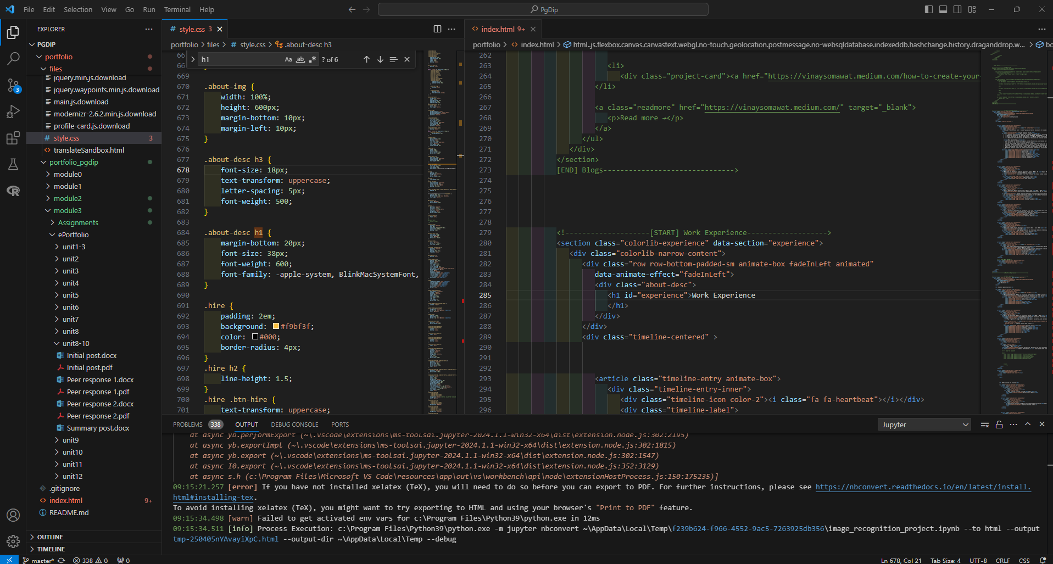

**Figure 4 – Using Git BASH to handle ePortfolio files**

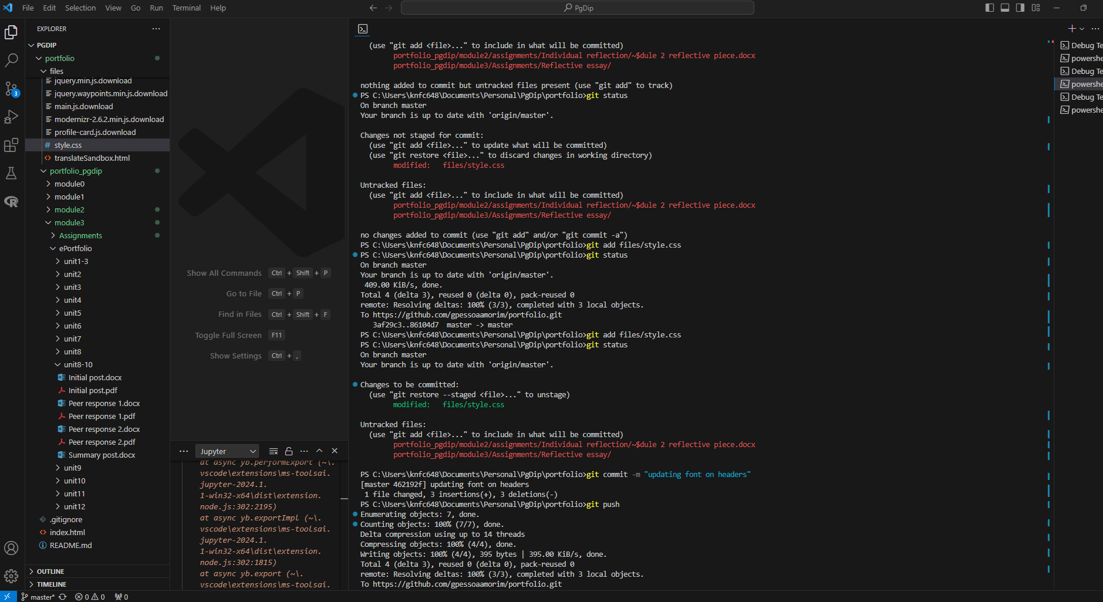

# Personal reflection on learning journey (“SO WHAT”)

I have a PhD in health data science and am proficient in R, but not Python. Therefore, this module provided a significant challenge in technical terms, but which I thoroughly enjoyed. I now feel much more confident using Python for a variety of tasks, but this was a steep learning curve since syntax and debugging mechanisms are quite different from R.

I honed many of these skills in the team project, in which I was responsible for most of the coding work. I also got to experience the benefits and challenges of managing a wider development team, such as balancing quite different backgrounds, availabilities, and though processes across the group to produce a coherent final product that harnessed of everyone’s views and contributions.

I was surprised by how simple building complex deep learning models using Python proved to be technically, but conversely how difficult it is to properly design and train an appropriate machine learning model, especially when employing complex architectures. This was particularly evident in the individual project, where I was able to easily put together a very complex convolutional neural network, but spent weeks trying to understand why my model was failing to learn appropriately. I eventually resorted to ChatGPT for support, and was able to quickly find and successfully apply some solutions. This made me reflect upon the AI feedback loop I experienced, which will become more pronounced as large language models continue to improve, eventually reaching a point where they may not only improve themselves but also create intelligent agents (for the common good, or not).

For the ePortfolio, I took a comprehensive approach by creating a full online page to showcase my CV and all work produced for this course, rather than just a simple collection of current module outputs. I saw this as an opportunity to tackle a long-standing desire of having a professional webpage, and simultaneously expand my toolkit to include web design with HTML and CSS, two programming languages I had never used. This allowed me to tailor my programming learning journey with a practical perspective, an approach which helps improve educational outcomes (Pane et al., 2017; Inthanon and Wised, 2024; Juniarni et al., 2024) and generates wider cognitive benefits (Von Hausswolff, Eckerdal and Thuné, 2020; Scherer, Siddiq and Sánchez-Scherer, 2021).

Besides the technical aspects, I also enjoyed the reflective work undertaken for the collaborative discussions, which allowed me to think upon the capabilities and wider implications of the models I was building, as well as the need to ensure that AI development is performed in a careful and thoughtful way, but also to benefit from the diverse perspectives and concrete examples contributed by my colleagues.

I was unfortunately not able to engage with the live seminar discussions due to caring responsibilities, but made sure I always reviewed all recordings. This allowed me to better prepare for assignment submissions, but I was disappointed at not being able to participate in the live discussions. More broadly, I was faced with significant challenges throughout this module due to caring for a small child, family illness, moving home, and transitioning between jobs (including switching to a new computer halfway through the individual project, and facing technical issues during submission). I tried to compensate for this with careful time management and intense independent study, which I believe was reflected in my submissions.

# Learning and changed actions (“NOW WHAT”)

This module provided a valuable and intense learning process, driven by the practical implementation of machine learning models in Python, my independent exploration of web-design in HTML/CSS, and engaging with other students in the team project and reflective discussions. I expanded my coding portfolio across several languages, learnt about the importance of tailored and thoughtful model development, developed valuable teamwork and reflective skills, and became a generally more confident coder and analyst. Going forward, I aim to apply these learnings in my new position as a data scientist within the pharmaceutical industry, where I will be working with multiple and diverse data sources for both descriptive and predictive analytics, likely integrating R and Python for data manipulation and model building, and using Git for version control within complex projects. Having experienced its capabilities first-hand, I also plan to integrate ChatGPT within my workflows for a wide range of tasks spanning from code building to text summarisation.

# Conclusion

I have greatly enjoyed the learning journey undertaken during this module, which greatly enhanced my technical, teamwork, and critical thinking abilities. The challenges I encountered and the solutions developed have prepared me to more confidently approach future machine learning projects and bolster my career aspirations in AI and data science.

# References

Gibbs, G. (1988) *Learning by doing: a guide to teaching and learning methods*. Oxford: Further Education Unit, Oxford Polytechnic.

Inthanon, W. and Wised, S. (2024) ‘Tailoring Education: A Comprehensive Review of Personalized Learning Approaches Based on Individual Strengths, Needs, Skills, and Interests’, *Journal of Education and Learning Reviews*, 1(5), pp. 35–46. Available at: https://doi.org/10.60027/jelr.2024.779.

Juniarni, C. *et al.* (2024) ‘The Importance of Personalized Learning: How to Tailor Education to the Individual Needs of Students’, *Education Studies and Teaching Journal (EDUTECH)*, 1(1). Available at: https://doi.org/10.62207/agxhq160.

Pane, J.F. *et al.* (2017) *Informing Progress - Insights on Personalized Learning Implementation and Effects*. RAND. Available at: https://www.rand.org/pubs/research_reports/RR2042.html.

Rolfe, G., Freshwater, D. and Jasper, M. (2001) *Critical reflection in nursing and the helping professions: a user’s guide.* Basingstoke.

Scherer, R., Siddiq, F. and Sánchez-Scherer, B. (2021) ‘Some Evidence on the Cognitive Benefits of Learning to Code’, *Frontiers in Psychology*, 12, p. 559424. Available at: https://doi.org/10.3389/fpsyg.2021.559424.

Von Hausswolff, K., Eckerdal, A. and Thuné, M. (2020) ‘Learning to program hands-on: a controlled study’, in *Koli Calling ’20: Proceedings of the 20th Koli Calling International Conference on Computing Education Research*. *Koli Calling ’20: 20th Koli Calling International Conference on Computing Education Research*, Koli Finland: ACM, pp. 1–10. Available at: https://doi.org/10.1145/3428029.3428058.